1. **Display snum,sname,city and comm of all salespeople.**

1. **Display all snum without duplicates from all orders.**

1. **Display names and commissions of all salespeople in london.**

1. **All customers with rating of 100.**

1. **Produce orderno, amount and date form all rows in the order table.**

1. **All customers in San Jose, who have rating more than 200.**

1. **All customers who were either located in San Jose or had a rating above 200.**

1. **All orders for more than $1000.**

1. **Names and citires of all salespeople in london with commission above 0.10.**

1. **All customers excluding those with rating <= 100 unless they are located in Rome.**

1. **All salespeople either in Barcelona or in london.**

1. **All salespeople with commission between 0.10 and 0.12. (Boundary values should be excluded)**

1. **All customers with NULL values in city column.**



1. **All orders taken on Oct 3Rd and Oct 4th 1994.**

1. **All customers serviced by peel or Motika.**

1. **All customers whose names begin with a letter from A to B.**



1. **All orders except those with 0 or NULL value in amt field.**

1. **Count the number of salespeople currently listing orders in the order table.**

1. **Largest order taken by each salesperson, datewise.**

1. **Largest order taken by each salesperson with order value more than $3000.**

1. **Which day had the hightest total amount ordered.**

1. **Count all orders for Oct 3rd.**

1. **Count the number of different non NULL city values in customers table.**

1. **Select each customer’s smallest order.**

1. **First customer in alphabetical order whose name begins with G.**

1. **Get the output like “ For dd/mm/yy there are ___ orders.**

1. **Assume that each salesperson has a 12% commission. Produce order no., salesperson no., and amount of salesperson’s commission for that order.**

1. **Find highest rating in each city. Put the output in this form. For the city (city), the highest rating is : (rating).**

1. **Display the totals of orders for each day and place the results in descending order.**

1. **All combinations of salespeople and customers who shared a city. (ie same city).**

1. **Name of all customers matched with the salespeople serving them.**

1. **List each order number followed by the name of the customer who made the order.**

1. **Names of salesperson and customer for each order after the order number.**

1. **Produce all customer serviced by salespeople with a commission above 12%.**

1. **Calculate the amount of the salesperson’s commission on each order with a rating above 100.**

1. **Find all pairs of customers having the same rating.**

1. **Find all pairs of customers having the same rating, each pair coming once only.**

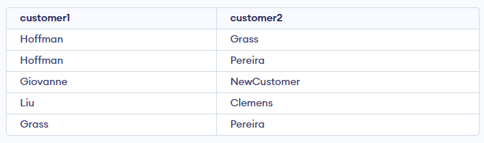

1. **Policy is to assign three salesperson to each customers. Display all such combinations.**

1. **Display all customers located in cities where salesman serres has customer.**

1. **Find all pairs of customers served by single salesperson.**

1. **Produce all pairs of salespeople which are living in the same city. Exclude combinations of salespeople with themselves as well as duplicates with the order reversed.**

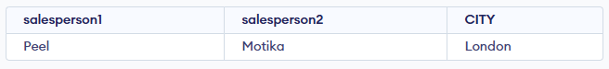

1. **Produce all pairs of orders by given customer, names that customers and eliminates duplicates.**

1. **Produce names and cities of all customers with the same rating as Hoffman.**

1. **Extract all the orders of Motika.**

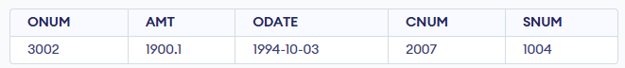

1. **All orders credited to the same salesperson who services Hoffman.**

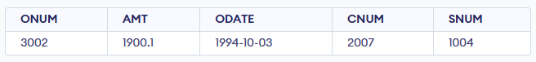

1. **All orders that are greater than the average for Oct 4.**

1. **Find average commission of salespeople in london.**

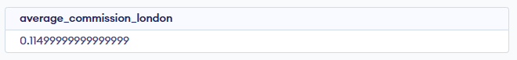

1. **Find all orders attributed to salespeople servicing customers in london.**

1. **Extract commissions of all salespeople servicing customers in London.**

1. **Find all customers whose cnum is 1000 above the snum of serres.**

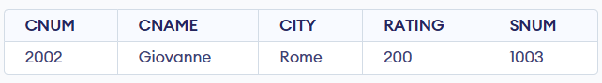

1. **Count the customers with rating above San Jose’s average.**

1. **Obtain all orders for the customer named Cisnerous. (Assume you don’t know his customer no. (cnum)).**



1. **Produce the names and rating of all customers who have above average orders.**

1. **Find total amount in orders for each salesperson for whom this total is greater than the amount of the largest order in the table.**

1. **Find all customers with order on 3rd Oct.**

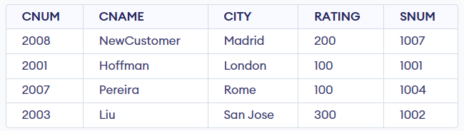

1. **Find names and numbers of all salesperson who have more than one customer.**

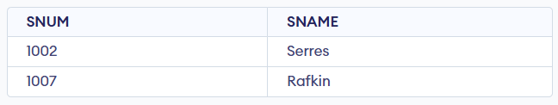

1. **Check if the correct salesperson was credited with each sale.**

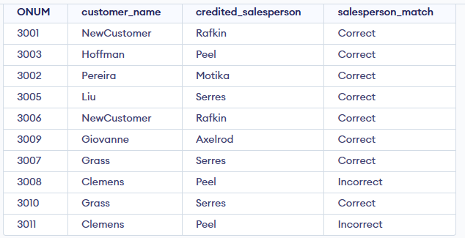

1. **Find all orders with above average amounts for their customers.**

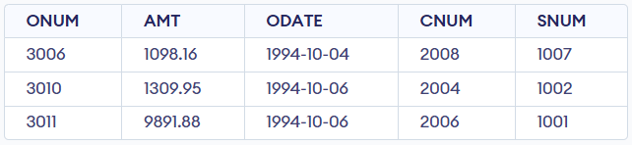

1. **Find the sums of the amounts from order table grouped by date, eliminating all those dates where the sum was not at least 2000 above the maximum amount.**



1. **Find names and numbers of all customers with ratings equal to the maximum for their city.**

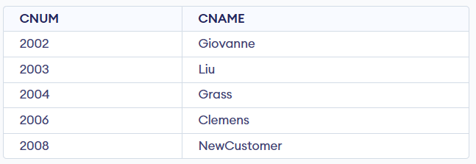

1. **Find all salespeople who have customers in their cities who they don’t service. ( Both way using Join and Correlated subquery.)**

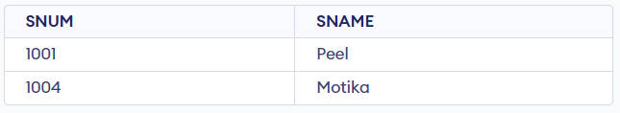

1. **Extract cnum,cname and city from customer table if and only if one or more of the customers in the table are located in San Jose.**

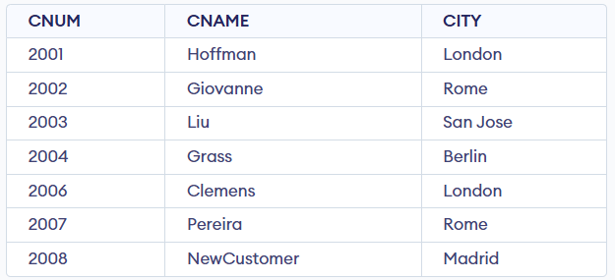

1. **Find salespeople no. who have multiple customers.**

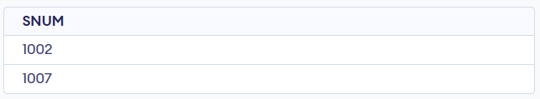

1. **Find salespeople number, name and city who have multiple customers.**

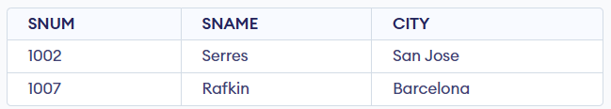

1. **Find salespeople who serve only one customer.**

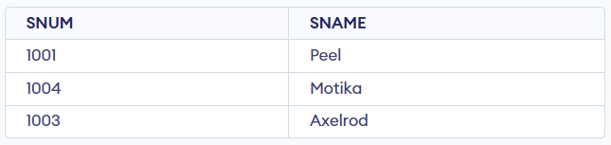

1. **Extract rows of all salespeople with more than one current order.**

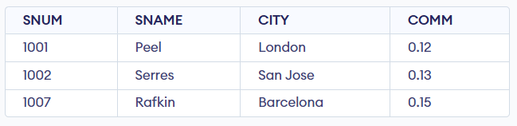

1. **Find all salespeople who have customers with a rating of 300. (use EXISTS)**

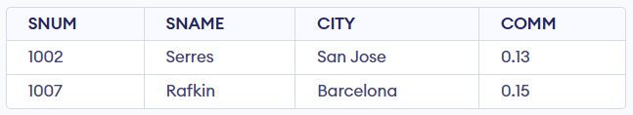

1. **Find all salespeople who have customers with a rating of 300. (use Join).**

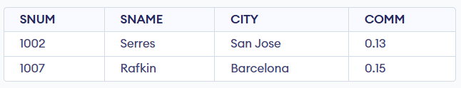

1. **Select all salespeople with customers located in their cities who are not assigned to them. (use EXISTS).**

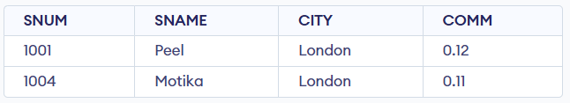

1. **Extract from customers table every customer assigned the a salesperson who currently has at least one other customer ( besides the customer being selected) with orders in order table.**

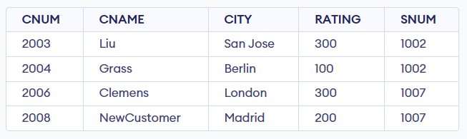

1. **Find salespeople with customers located in their cities ( using both ANY and IN).**

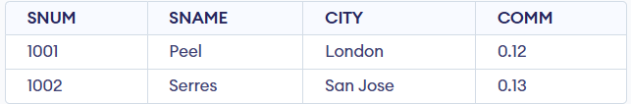

1. **Find all salespeople for whom there are customers that follow them in alphabetical order. (Using ANY and EXISTS)**

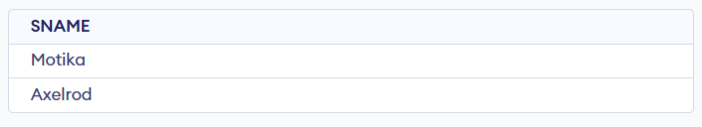

1. **Select customers who have a greater rating than any customer in rome.**

1. **Select all orders that had amounts that were greater that atleast one of the orders from Oct 6th.**

1. **Find all orders with amounts smaller than any amount for a customer in San Jose. (Both using ANY and without ANY)**

1. **Select those customers whose ratings are higher than every customer in Paris. ( Using both ALL and NOT EXISTS).**

SQL query successfully executed. However, the result set is empty.

1. **Select all customers whose ratings are equal to or greater than ANY of the Seeres.**

1. **Find all salespeople who have no customers located in their city. ( Both using ANY and ALL)**

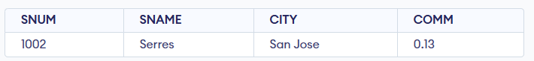

1. **Find all orders for amounts greater than any for the customers in London.**

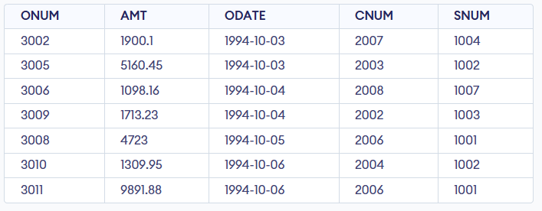

1. **Find all salespeople and customers located in london.**

1. **For every salesperson, dates on which highest and lowest orders were brought.**

1. **List all of the salespeople and indicate those who don’t have customers in their cities as well as those who do have.**

1. **Append strings to the selected fields, indicating weather or not a given salesperson was matched to a customer in his city.**

1. **Create a union of two queries that shows the names, cities and ratings of all customers. Those with a rating of 200 or greater will also have the words ‘High Rating’, while the others will have the words ‘Low Rating’.**

1. **Write command that produces the name and number of each salesperson and each customer with more than one current order. Put the result in alphabetical order.**

1. **Form a union of three queries. Have the first select the snums of all salespeople in San Jose, then second the cnums of all customers in San Jose and the third the onums of all orders on Oct. 3. Retain duplicates between the last two queries, but eliminates and redundancies between either of them and the first.**

1. **Produce all the salesperson in London who had at least one customer there.**

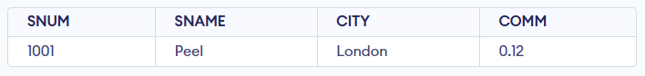

1. **Produce all the salesperson in London who did not have customers there.**

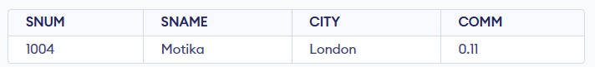

1. **We want to see salespeople matched to their customers without excluding those salesperson who were not currently assigned to any customers. (User OUTER join and UNION)**

